Git and GitHub

How to setup git for directory.

Note :-

1. We note use any space in the file name, you only use the “_”,”camel case<just like ‘MyNameIsDan’>”.
2. If you can use the space, so you use backslash “\” just like <my\ name\ is\ dan>.

----------------------------------------------------------------------------------------------------------------

1. we can download the git in Linux.

Point:-

(1) open the Terminal to use the shortcut key(ctrl + alt = t).

(2) then you written the commant.

$ sudo apt-get install git

$ <password>

(3)then you see that git install in your computer.

----------------------------------------------------------------------------------------------------------------

1. how to check Git.

Point:-

1. open the Terminal and written the commant.

$ git

-----------------------------------------------------------------------------------------------------------------------------------

1. when you use git first time, so git need your name and email id.

Point:-

1. Open the terminal and follow the commant.

$ git config --global user.name <enter the user name>

$ git config --gobal user.email<enter the user email id >

-----------------------------------------------------------------------------------------------------------------------------------

1. Go to the folder which you want to use git

$ git init => this will initialize git in that folder and “.git ” file will created

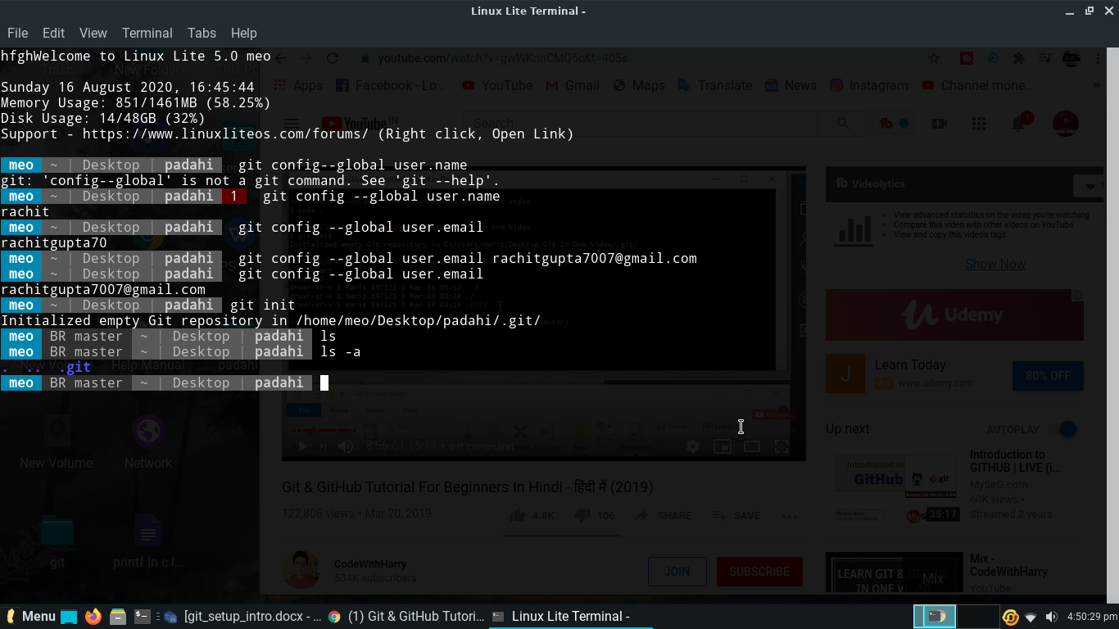

1. The structure of git .
2. Untracked is file position than git is do not mean the untracked. If you want to add your file then git started to save the file.
3. Staged is like a field those file is come under the commit. Commit is those position that git is record the file in your computer.
4. Unmodified
5. Modified

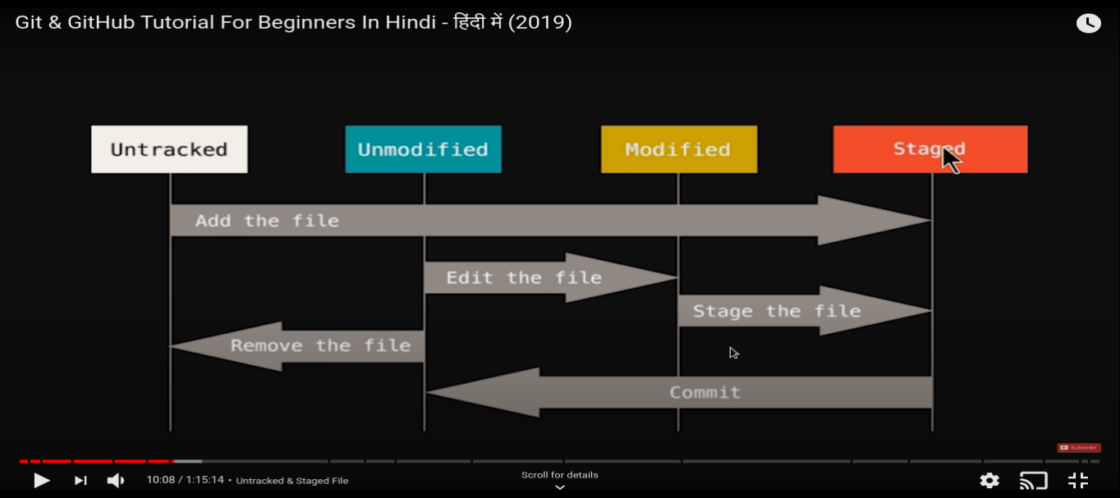

1. We can use git status to check the file”file is add or not” in the directory.

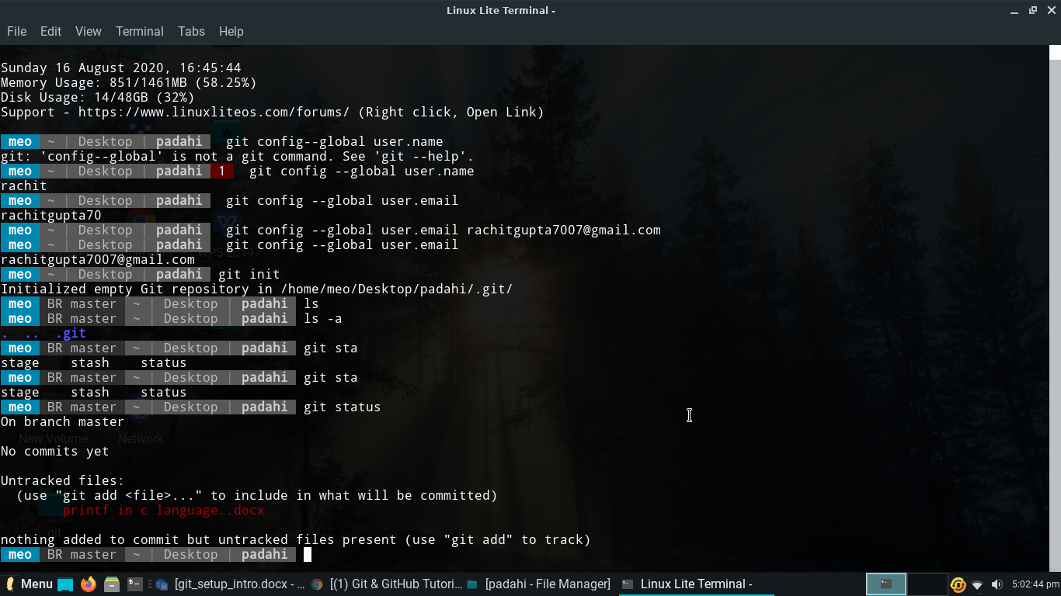

1. How to add file in git. When you add the file with use this commant.

$ git add <file name>

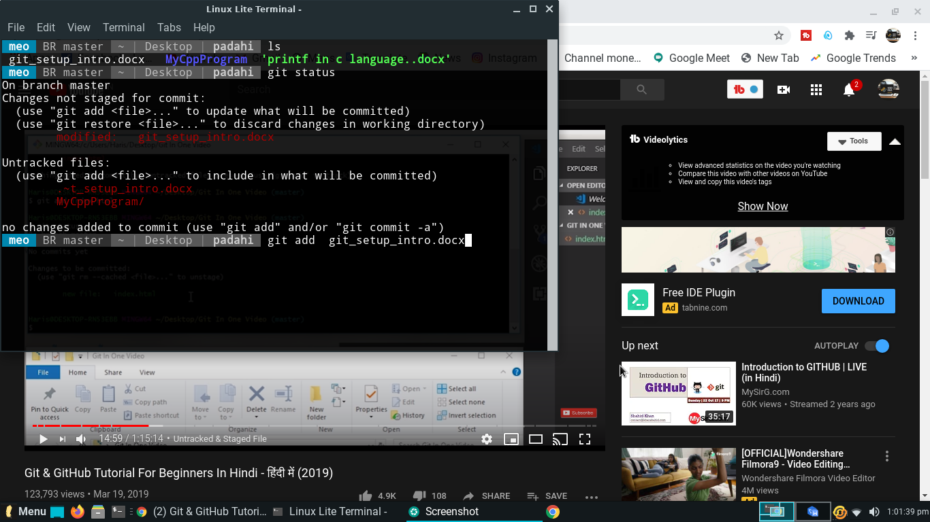

1. When you add file then we commit the file to git save record of file.

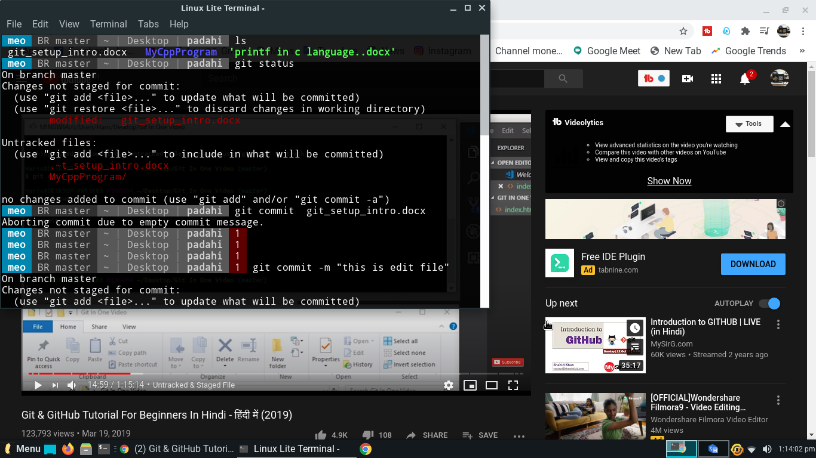

1. How to add and commit two or more file in git.

(1)When you have two or many file to add the file in git, so you use this commant.

$ git add -A

1. when you add the file and you want to commit the file, so you use this commant

$ git commit -a -m ”write a massage”

1. Then you check the file with using this commant and than you see your all file is commit.

$ git status

1. What is git checkout commant ?

:- git checkout commant is check the working directory match with last commit.

:- if your all file is rewrite by anybody and you want to restore the file, so you use this commant.

$ git checkout => for single file.

$git checkout -f => for all file.

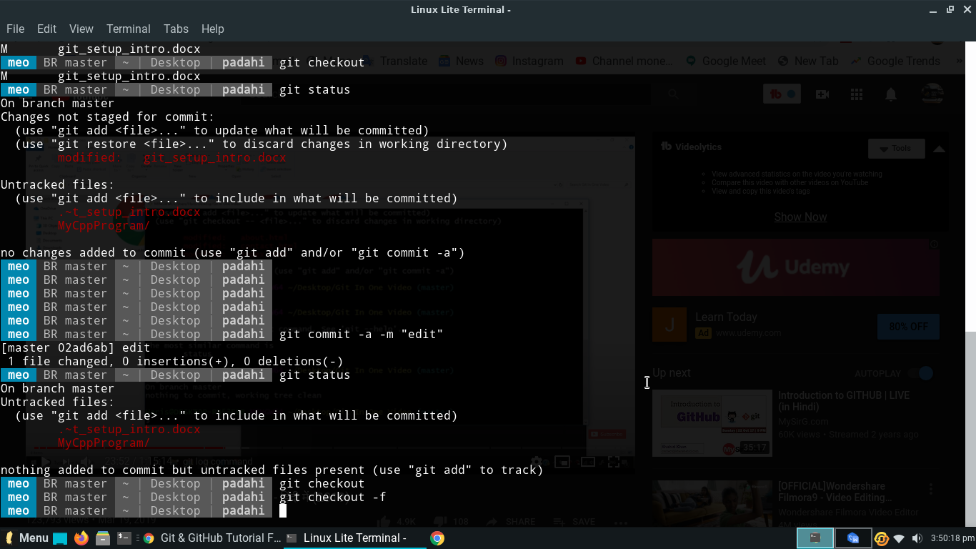

1. If want to show my all commit wen you are start using git, so using this commant.

$ git log

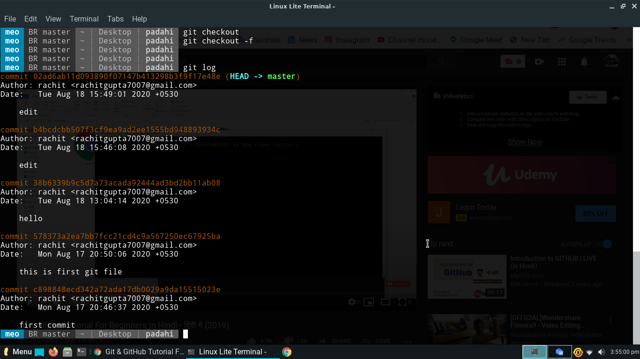

1. If want to show my any last commit and it changes, so use this commant.’

$ git log -p -<any last>

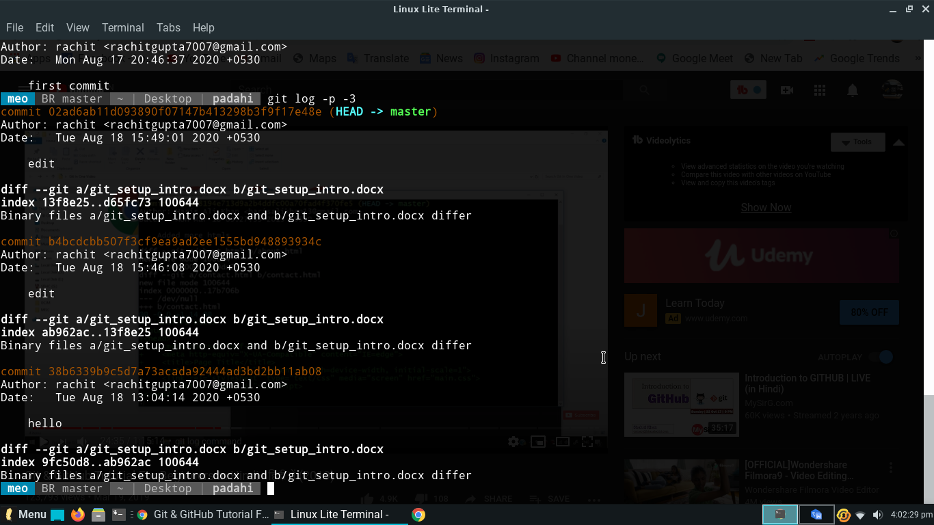

You see that your last 3 commit.

1. Git diff :-
2. How to remove the file in git and permanent remove in the disk.
3. Suppose We can make temporary files his name <Waste file.docx> and this file is add in git and also commit it.

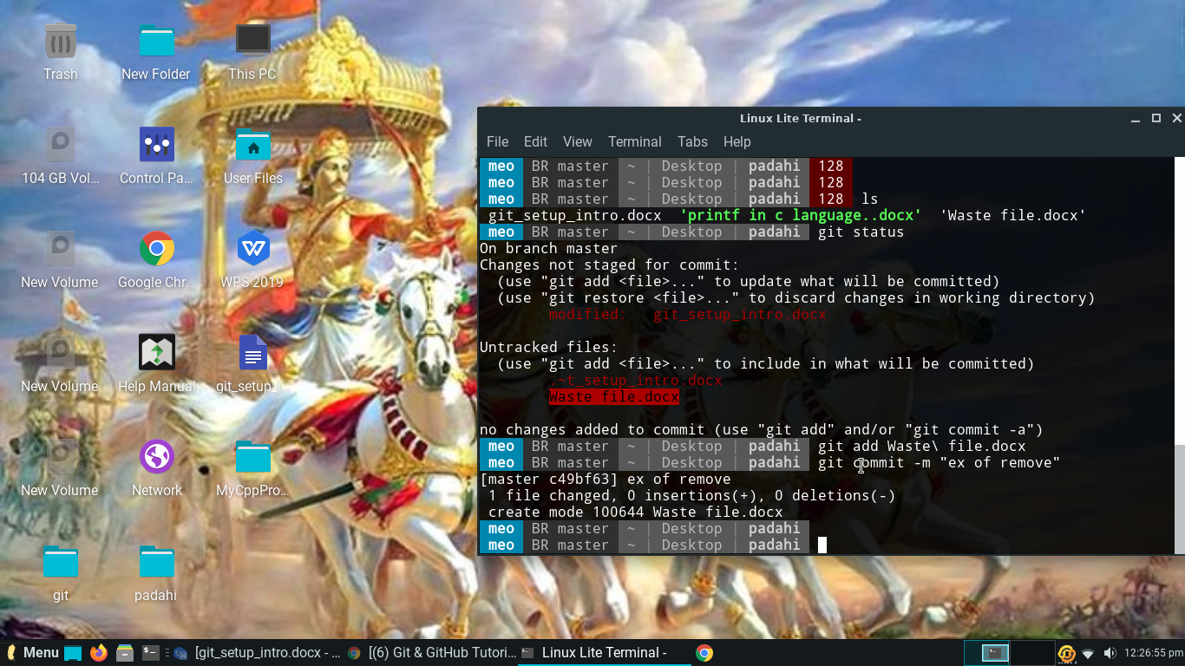

1. When we want to remove this file,so use this command

$ git rm --cached <file name> => this command is use when you want to remove file in git.

(1) 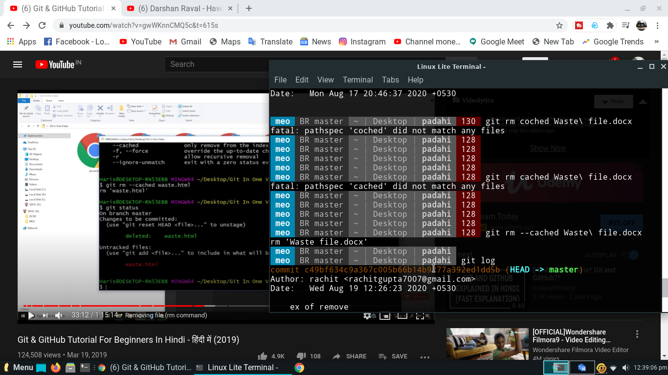

(2)

